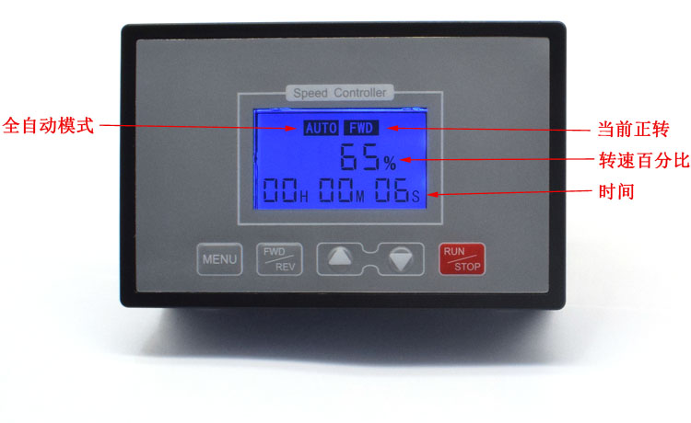
Product Parameters:

Product name: Smart T89
Input voltage: DC10-55V (the specific voltage is equal to the rated voltage of the motor)
Output voltage: linear under load
Instantaneous current: 60A
Continuous current: within 40A
Forward and reverse: support the support
Wireless remote control: Yes
Timing time: yes
Limit function: Yes
Slow start and stop: It can be set to set
Rotation speed digital display: 0-100 percentage table
Speed ​​regulation type: flow regulation
Speed ​​adjustment method: jog +-
Speed ​​adjustment range: 0-100%
Control frequency: 15KHZ
Wiring type: Barrier terminal block
Support motor: brushed motor
Module size: length*width*height 148mm*95mm*36mm
Product net weight: 255 grams
Panel opening: length*width 142mm*88mm
Installation method: Embedded

Note:
1. The input must be divided into positive and negative. The input voltage must be equal to the rated voltage of the motor (within 10-55V). For example, the rated voltage of the motor 12V is input to the governor 12V, and the rated voltage of the motor 36V is input to the governor voltage 36V.
2. Input 220V will be damaged.

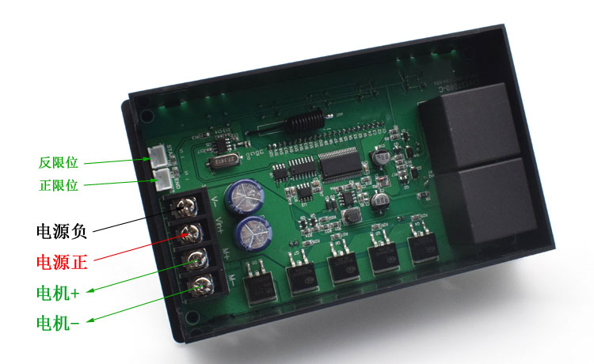
The wiring of the two-wire and three-wire limit switch is as follows:

Support normally open mechanical switch, NPN type photoelectric switch, metal proximity switch, Hall magnetic control switch

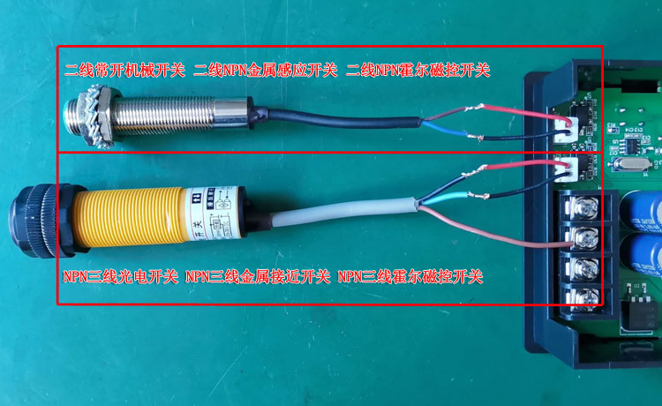

Long press the FWD/REV button to turn off the backlight

If you need reverse start, press FWD/REV reverse start

The functions of 0-1-2-3-4-5-6-7-8-9-E are set as follows:

Manual and automatic mode selection Function 0：
1 is manual mode, 2 is automatic mode, the default is 1 manual mode.

Slow start time setting Function1：
000-100 The time from slow start to 100% speed is adjustable between 0-10 seconds, and the default is 1 second.
Slow stop time setting Function2：
000-100 The slow stop time is adjustable between 0-10 seconds, and the default is 1 second.
Speed lower limit setting Function 3：
000-080 The minimum speed is adjustable between 0-80%, and is less than the maximum speed setting value, the default is 0.

Speed limit setting Function 4：
000-100 The maximum speed is adjustable between 0-100%, and is greater than the minimum speed setting value, the default is 100%.

Acceleration and deceleration value setting Function 5：
001 002 005 010 015 020 025
Each time you press the plus and minus key, the speed changes accordingly1%,2%,5%,10%,15%,20%,25%。

Motor running time setting Function 6：
1 second minimum, 99 hours 59 minutes 59 seconds maximum, the default is 99 hours 59 minutes 59 seconds.

The following function 7.8.9. is the time setting in the fully automatic mode

Forward time setting Function 7：
0 seconds minimum, 99 hours maximum, default is 10 seconds

Stop time setting Function 8：
0 seconds minimum, 99 hours maximum, default is 10 seconds

Reverse time setting Function 9：
0 seconds minimum, 99 hours maximum, default is 10 seconds

Limit mode selection Function E:

E1: Infinite position Default infinite position
E2: Press to start the motor to rotate forward, to rotate to the positive limit, and the motor to stop, press to start to reverse
E3: Press to start the motor forward rotation, forward rotation to positive limit, motor reverse rotation, reverse rotation to negative limit, motor stop
E4: Press to start the motor forward rotation, forward rotation to positive limit, the motor reverse rotation, and work in a cycle

Manual and automatic mode selection Press the MENU button 1 times to display 0 Enter manual and automatic mode selection 1 for manual mode 2 for automatic mode Press the plus and minus keys to switch Press RUN/STOP to save and exit
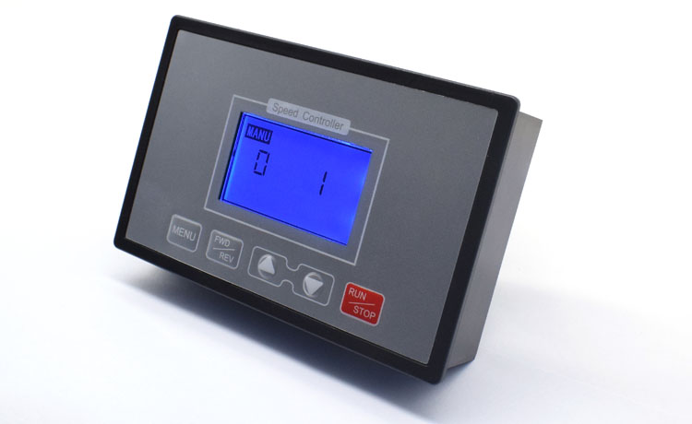

Slow start time setting Press the MENU button 2 times to enter the function 1 setting key surface Press the plus and minus buttons to set the time Press RUN/STOP to save and exit (10 is 1 second, 100 is 10 seconds)
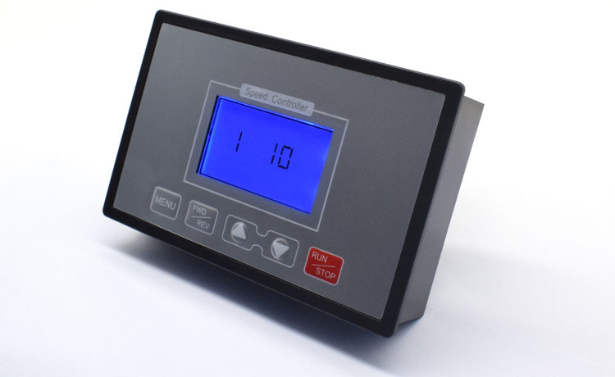

Slow stop time setting Press the MENU button 3 times to enter the function 2 setting key surface Press the plus and minus keys to set the time Press RUN/STOP to save and exit (10 is 1 second, 100 is 10 seconds)
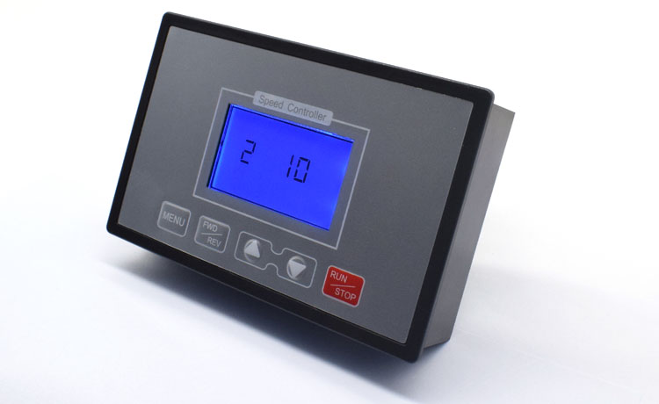

Set the lower limit of speed Press the MENU button 4 times to enter the function 3 key surface Press the plus and minus keys to set Press RUN/STOP to save and exit
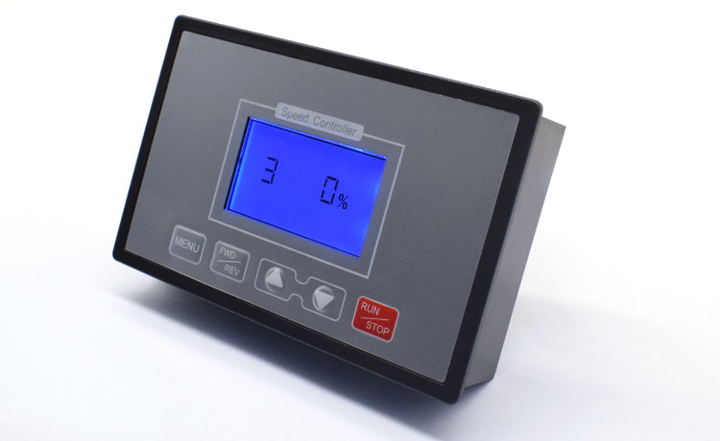
Speed limit setting Press the MENU button 5 times to enter the function 4 key surface Press the plus and minus keys to set the size value Press RUN/STOP to save and exit.
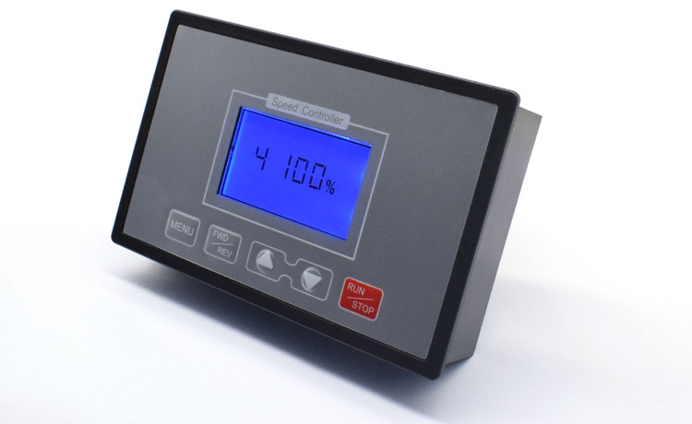
Set acceleration and deceleration value Press the MENU key 6 times to enter the function 5 key surface Press the plus and minus keys to switch Press RUN/STOP to save and exit
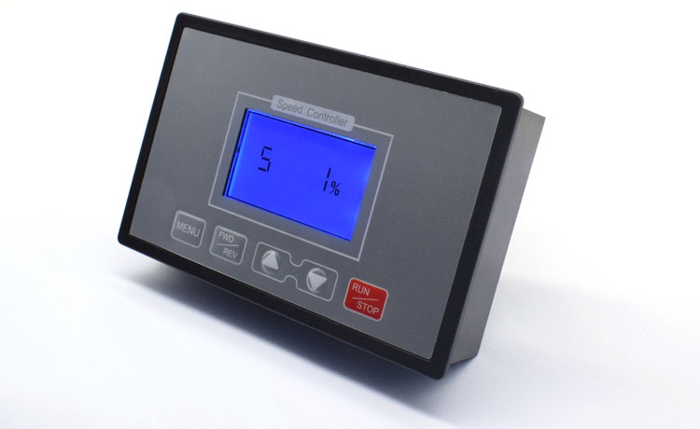
Motor running time setting
Press the MENU button 7 times to enter the function 6 interface, the default is the maximum time 99 hours 59 minutes 59 seconds
FWD/REV key switch hour/minute/second

Press the plus/minus key to adjust the hour/minute/second size
Press RUN/STOP to save and exit
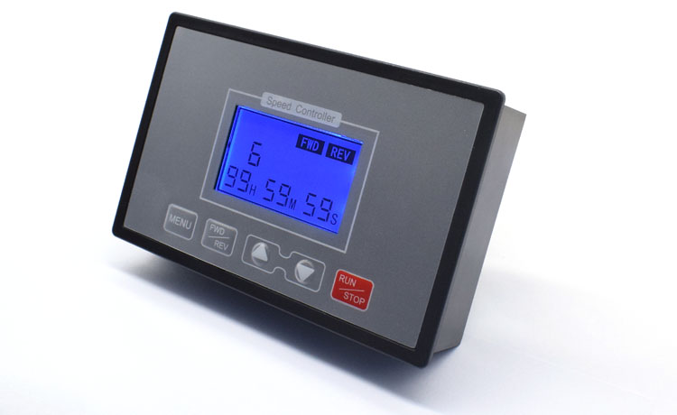

Function 7 Forward rotation time setting in fully automatic mode

Press the MENU key 8 times to enter the function 7 interface
The default is the maximum time 0 hour 0 minute 10 seconds
FWD/REV key switch hour/minute/second.
Press the plus/minus key to adjust the hour/minute/second size
Press RUN/STOP to save and exit.
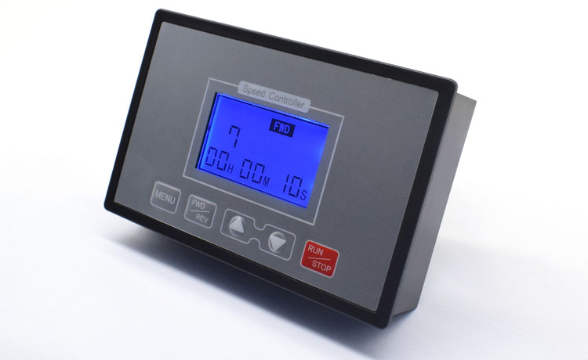
Function 8 Stop rotation time setting in fully automatic mode
Press the MENU key 9 times to enter the function 8 interface
The default is the maximum time 0 hour 0 minute 0 second
FWD/REV key switch hour, minute, second.

Adjust the hour/minute/second by adding or subtracting
Press RUN/STOP to save and exit.

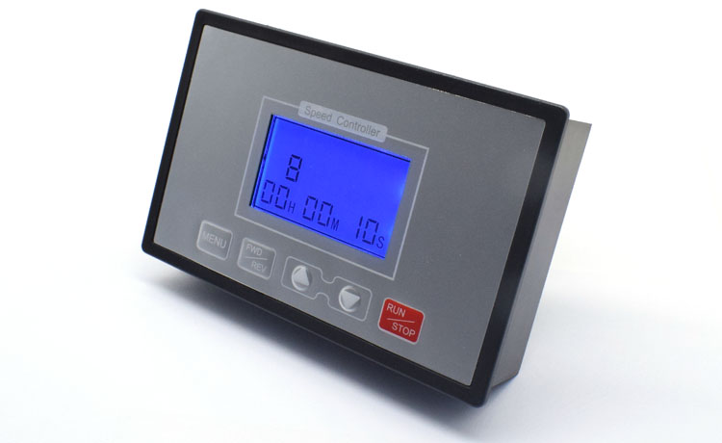

Function 9: Reverse time setting in fully automatic mode

Press the MENU key 10 times to enter the function 9 key surface The default is the maximum time 0 hour 0 minute 10 seconds FWD/REV key to switch hours / minutes / seconds

Adjust the hour/minute/second by adding or subtracting
Press RUN/STOP to save and exit
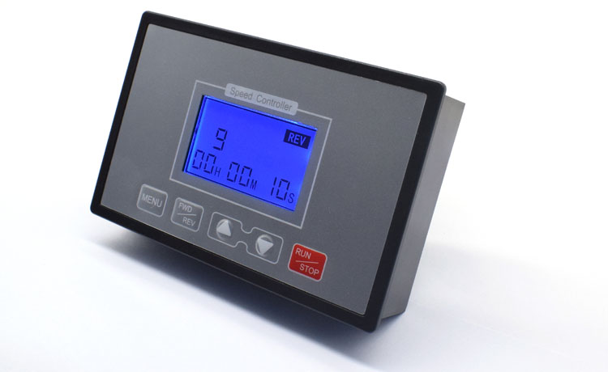

Function E Limit mode selection E1 E2 E3 E4

Press the MENU button 11 times to enter the function interface
The default is E1 unlimited digits
Press plus/minus to switch E1 E2 E3 E4
Press RUN/STOP to save and exit

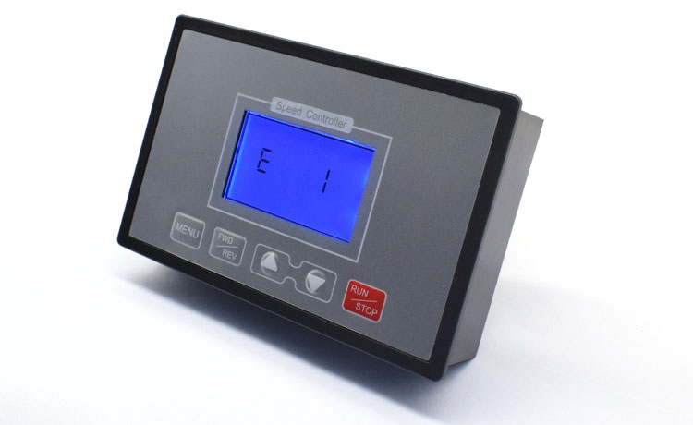
E2 function: Press to start the motor to rotate forward, to rotate to the positive limit, the motor to stop, press to start to reverse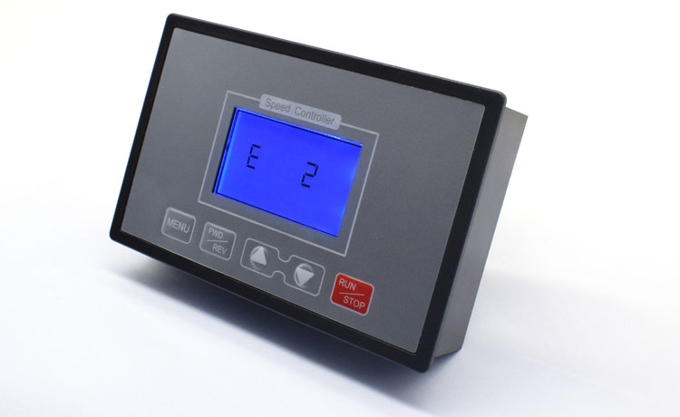E3 function: according to the starting motor forward rotation, forward rotation to positive limit motor reverse rotation, reverse rotation to reverse limit motor stop

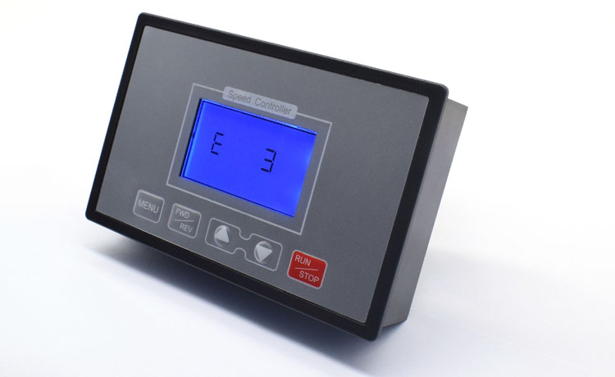

E4 function: according to the starting motor forward rotation, forward rotation to the positive limit motor reverse rotation cycle work
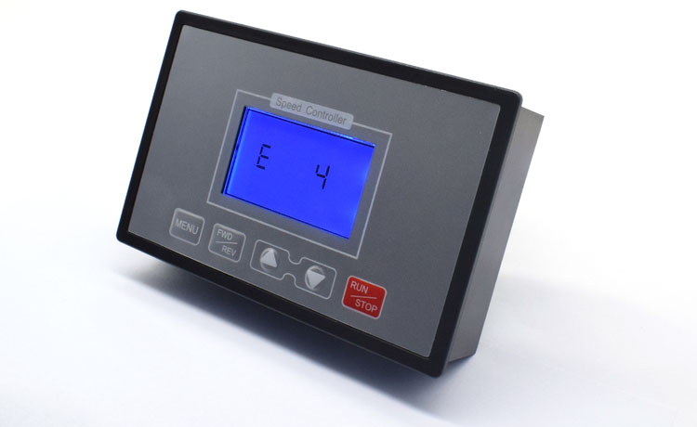

Size:

